DIRECT AND INDIRECT SPEECH

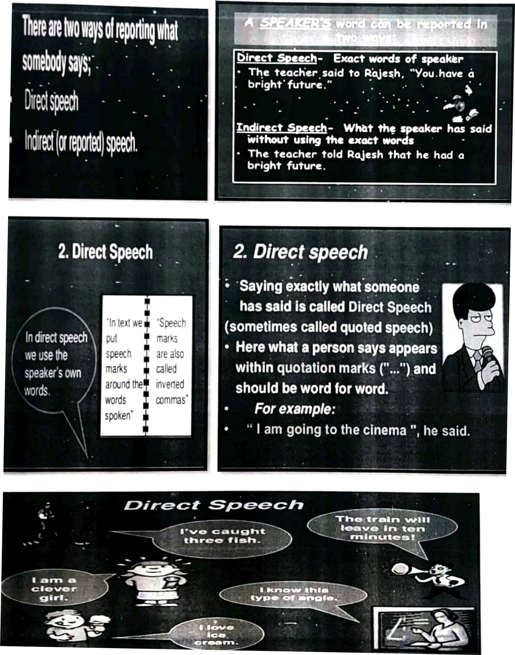

WHAT IS DIRECT &INDIRECT SPEECH?
- Direct speech reporting the message of the speaker in the exact words as spoken by him.
- Direct speech example: Maya said 'l am busy now'.
- Indirect speech: reporting the message of the speaker in our own words
- Indirect speech example: Maya said that she was busy then.

Rules | Direct speech | Indirect speech
Rule 1: All the present tenses are  changed to the corresponding past tense in indirect speech. | She said, 'l am happy'. | She said that she was happy.
Rule 2: Present Perfect Changes to Past Perfect. | have been to Boston", she told me. | She told me that she had been to Boston.
Rule 3: Present Continuous Changes to Past Continuous | I am playing the guitar", she explained | She explained that she was playing the guitar.
Rule 4: Present Perfect Changes to Past Perfect | He said, "She has finished her homework". | He said that she had finished her homework.
Rule 5: Simple Past Changes to Past Perfect | She said, "Irvin arrived on Sunday." | She said that Irvin had arrived on Sunday.
Rule 6: Past Continuous Changes to Past Perfect Continuous | We were playing basketball", they told me. | They told me that they had been playing basketball.
Rule 7: Future Changes, to Present Conditional | She said, "l will be in  Scotland tomorrow." | She said that she would be in Scotland the next day.

ll. Direct Speech to Indirect Speech Conversion — Interrogative Sentences
- Direct: "Where do you live?" asked the boy.
- Indirect: The boy enquired where I lived.

- Direct: She said, 'Will you come for the party'?
- Indirect: She asked whether (OR) if she would come for the party.

- Direct: He said to me, 'What are you wearing'?
- Indirect: He asked me what I was wearing.

Ill. Direct Speech to Indirect Speech Conversion — Changes in Modals
While changing direct speech to indirect speech, the modals used in the sentences change like:
- Can becomes could
- May becomes might
- Must become had to /would have to
Examples:
- Direct: She said, 'She can dance'.
- Indirect: She said that she could dance.

- Direct: She said, 'l may buy a dress'.
- Indirect: She said that she might buy a dress.

- Direct: Rama said, 'l must complete the assignment'.
- Indirect: Rama said that he had to complete the assignment.

IV. Direct Speech to Indirect Speech Conversion — Request, Command, Wish, Exclamation.
Indirect Speech is supported by some verbs like requested, ordered, suggested and advised. Forbid-forbade is used for negative sentences. Therefore, the imperative mood in the direct speech changes into the Infinitive in indirect speech.

- Direct: She said to her 'Please complete it'.
- Indirect: She requested her to complete it.

- Direct: Hamid said to Ramesh, 'Sit down'.
- Indirect: Hamid ordered Ramesh to sit down.

- Direct: She said, 'Alas! We lost "
- Indirect: she exclaimed sadly that they had lost.

Direct Speech to Indirect Speech Conversion — Change of Time
In direct speeches, the words that express nearness in time or place are changed to words that express distance in indirect speech. Such as:
- Now becomes then
- Here becomes there
- Ago becomes before
- Thus, becomes so
- Today becomes that day
- Tomorrow becomes the next day
- This becomes that
- Yesterday becomes the day before
- These become those
- Hither becomes thither
- Come becomes go
- Hence becomes thence
- Next week or month becomes following week/month

CHANGE THE FOLLOWING INTO INDIRECT SPEECH:

1. He said, "I like this song."
Ans: He said that he liked that song.

2. "Where is your sister?" she asked me.
Ans: She asked me where my sister was.

3. "l don't speak Italian," she said.
Ans: She said that she didn't speak Italian.

4."Say hello to Jim," they said
Ans: They told me to say hello to Jim.

5. "The film began at seven o'clock," he said.
Ans: He said that the film had begun at seven o'clock.

6."Don't play on the grass, boys," she said.
Ans: She told the boys not to play on the grass.

7."Where have you spent your money?" she asked him.
Ans: She asked him where he had spent his money.

8."l never make mistakes," he said.
Ans: He said that he never made mistakes.

9. "Does she know Robert?" he wanted to know.
Ans: He wanted to know if she knew Robert.

10."Don't try this at home," the stuntman told the audience.
Ans: The stuntman told the audience not to try that at home

11.The girl said, 'It gives me great pleasure to be here this evening.'
Ans: The girl said that it gave her great pleasure to be there that evening.

12.The man said, 'l must go as soon as possible.'
Ans: The man said that he had to go as soon as possible.

13.She said, 'l don't want to see any of you; go away.'
Ans: She said that she didn’t want to see any of them and told them to go away.

14.The teacher says, 'If you work hard, you will pass.
Ans: The teacher says that if we work hard, we will pass.

15. He said, 'l have won.
Ans: He said that he had won.

16.He said, 'Let's wait for her return.
Ans: He suggested that they should wait for her return.

17.Alice said, 'How clever I am!
Ans: Alice said how clever she was.

18.'Which way did she go?' asked the young man.
Ans: The young man asked which way she had gone.

19.He said to me, 'Where are you going?
Ans: He asked me where I was going.

20.Please wait here till I return,' she told him.
Ans: She told him to wait there till she returned.

21.He says, "l am ill."
Ans: He says that he is ill.

22.She says, "She sang a song."
Ans: She says that she sang a song.

23.They said, "They take a walk every day."
Ans: They said that they took a walk every day.

24.She said, "I'm leaving tomorrow".
Ans: She said that she was leaving the next day.

25.He said, "Please get me a cup of tea
Ans: He asked me to get him a cup of tea.

26."It is too late to apologize," I said.
Ans: I said that it was too late to apologize.

27."l cannot come to your birthday party," explained Mary
Ans: Mary explained that she could not come to my birthday party.

28.I will finish this picture tomorrow," said Diana.
Ans: Diana said that she would finish that picture the next day.

29.'You will have to surrender your passport,' the officer said to the passenger.
Ans: The officer told the passenger that he would have to surrender his passport.

30.'l saw an interesting film last evening,' said my friend.
Ans: My friend said that he had seen an interesting film the previous evening.

**********************************

